1**).BUG REPORTING**:

**Bug ID**: -1

**Module: -**Company Info:General.

**Sub-Module:-**Company Name.

[**URL:**http://172.16.10.77/hrm](URL:http://172.16.10.77/hrm).

**Bug Summary**:- Company name text field accepting alphanumeric along with special character.

**Bug- Description**:- Accepting alphanumeric along with special character.

**Steps to follow**:-

1. Launch the application with valid **URL--->(**<http://172.16.10.77/hrm>.)

**2.**Login with valid credentials . (**admin/admin**).

**3.Go to Admin->company->company Info: General-->company name.**

**4.Enter the data in company name text field(abc123*).**

**5.Click on ”Save” button.**

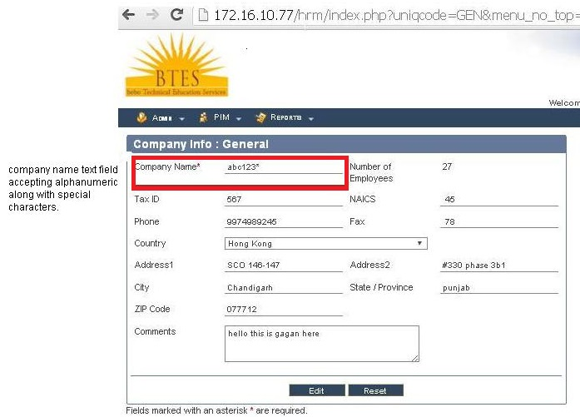

2**).BUG REPORTING**:-

**Bug ID**: -

**Module: -**Company Info:General.

**Sub-Module:-**Tax_Id.

[**URL:**http://172.16.10.77/hrm](URL:http://172.16.10.77/hrm).

**Bug Summary**:- Tax_ID text field accepting alphanumeric data along with special character.

**Bug- Description**:- Accepting alphanumeric data along with special character in Tax_Id text field.

**Steps to follow**:-

1. Launch the application with valid **URL--->(**<http://172.16.10.77/hrm>.)

**2.**Login with valid credentials . (**admin/admin**).

**3.Go to Admin->company->companyInfo:General-->Tax_id.**

**4.Enter the data in Tax_idtext field(abc123**)**

**5.Click on ”Save” button.**

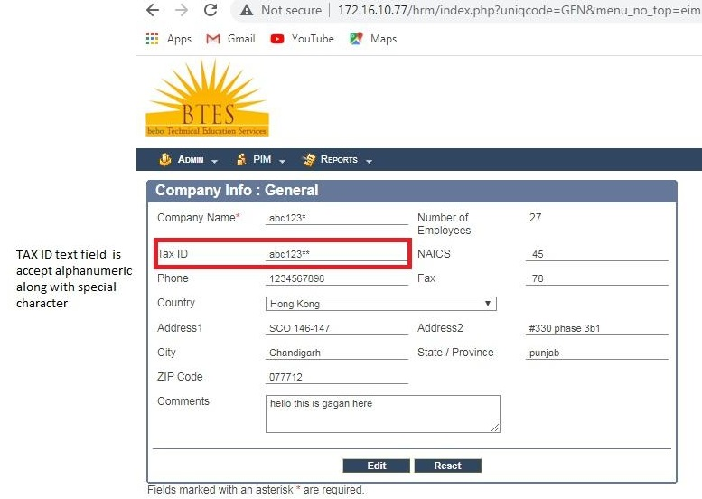

3**).BUG REPORTING**:-

**Bug ID**: -

**Module: -**Company Info:General.

**Sub-Module:-**Phone_No.

[**URL:**http://172.16.10.77/hrm](URL:http://172.16.10.77/hrm).

**Bug Summary**:- Phone _no text field accept greater than 13 digits.

**Bug- Description**:- Accept greater than 13 digits in Phone_no text field.

**Steps to follow**:-

1. Launch the application with valid **URL--->(**<http://172.16.10.77/hrm>.)

**2.**Login with valid credentials . (**admin/admin**).

**3.Go to Admin->company->companyInfo:General-->Phone_no.**

**4.Enter the data in Phone_no text field (12345678981223) .**

**5.Click on ”Save” button.**

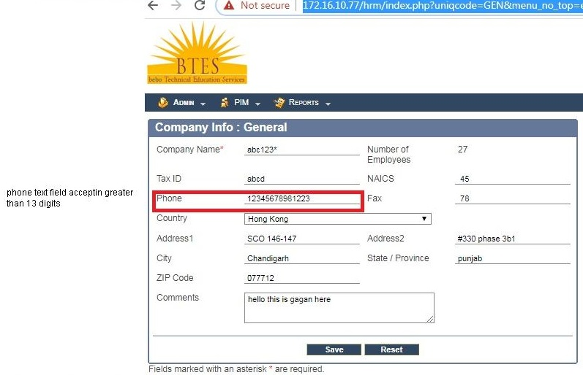

4).**BUG REPORTING**:-

**Bug ID**: -

**Module: -**Company Info:General.

**Sub-Module:-**Phone_No.

[**URL:**http://172.16.10.77/hrm](URL:http://172.16.10.77/hrm).

**Bug Summary**:- phone_no text field accept less than 13 digits.

**Bug- Description**:- Accept less than 13 digits in Phone_no text field.

**Steps to follow**:-

1. Launch the application with valid **URL--->(**<http://172.16.10.77/hrm>.)

**2.**Login with valid credentials . (**admin/admin**).

**3.Go to Admin->company->companyInfo:General-->Phone_no.**

**4.Enter the data in Phone_no text field (12345678981223) .**

**5.Click on ”Save” button.**

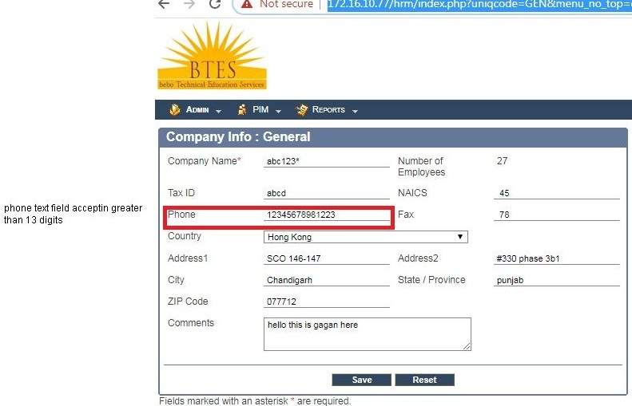

5).**BUG REPORTING**:-

**Bug ID**: -

**Module: -**Company Info:General.

**Sub-Module:-**Address.

[**URL:**http://172.16.10.77/hrm](URL:http://172.16.10.77/hrm).

**Bug Summary**:-Address text fields is accepting the numeric data .

**Bug- Description**:- Accepting numeric data in Address text field.

**Steps to follow**:-

1. Launch the application with valid **URL--->(**<http://172.16.10.77/hrm>.)

**2.**Login with valid credentials . (**admin/admin**).

**3.Go to Admin->company->companyInfo:General-->Address.**

**4.Enter the data in Address text field (12345) .**

**5.Click on ”Save” button.** 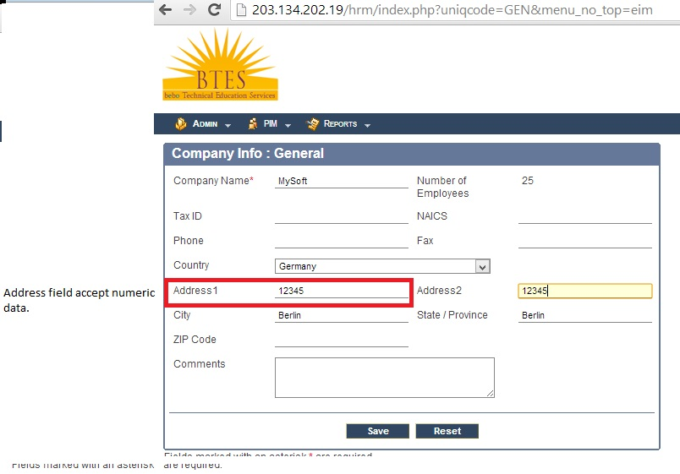

6).**BUG REPORTING**:-

**Bug ID**: -

**Module: -Company Info:General**.

**Sub-Module:-**Zip Code.

[**URL:**http://172.16.10.77/hrm](URL:http://172.16.10.77/hrm).

**Bug Summary**:- Zip code text field accepting the less than 5digits.

**Bug- Description**:- Accepting less than 13 digits in Zip code text field.

**Steps to follow**:-

1. Launch the application with valid **URL--->(**<http://172.16.10.77/hrm>.)

**2.**Login with valid credentials . (**admin/admin**).

**3.Go to Admin->company->General :-companyInfo-->Zip code.**

**4.Enter the data in zip code text field (768) .**

**5.Click on ”Save” button.**

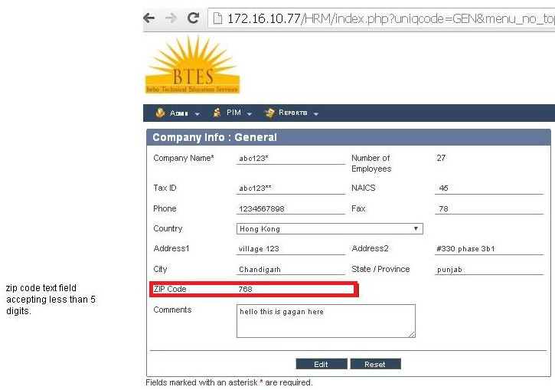

7).**BUG REPORTING**:-

**Bug ID**: -

**Module: -Company Info:General**.

**Sub-Module:-**Zip Code.

[**URL:**http://172.16.10.77/hrm](URL:http://172.16.10.77/hrm).

**Bug Summary**:- Zip code text field accepting the greater than 5digits.

**Bug- Description**:- Accepting greater than 13 digits in Zip code text field.

**Steps to follow**:-

1. Launch the application with valid **URL--->(**<http://172.16.10.77/hrm>.)

**2.**Login with valid credentials . (**admin/admin**).

**3.Go to Admin->company->General :-companyInfo-->Zip code.**

**4.Enter the data in zip code text field (768587) .**

**5. Click on ”Save” button.**

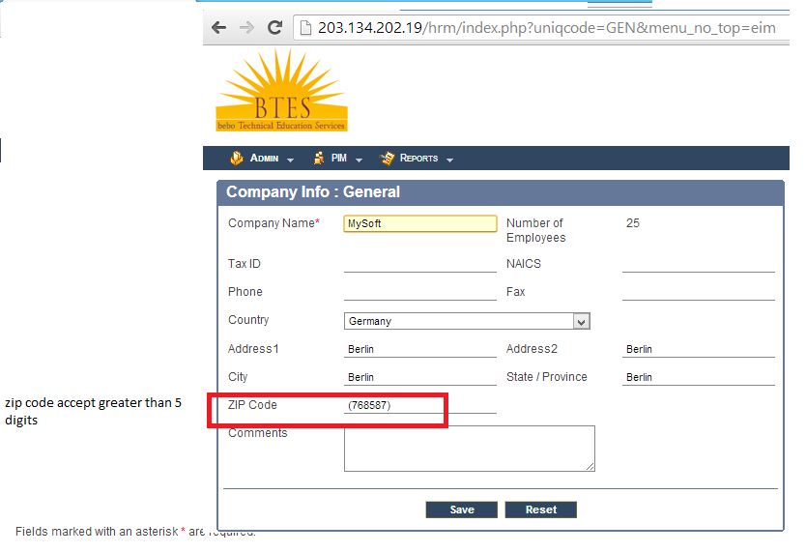

8).**BUG REPORTING**:-

**Bug ID**: -

**Module: -Company Info**.

**Sub-Module:-**Location.

[**URL:**http://172.16.10.77/hrm](URL:http://172.16.10.77/hrm).

**Bug Summary**:- Name text field accepting alphanumeric along with special character.

**Bug- Description**:- Accepting alphanumeric along with special character in text field.

**Steps to follow**:-

1. Launch the application with valid **URL--->(**<http://172.16.10.77/hrm>.)

**2.**Login with valid credentials . (**admin/admin**).

**3.Go to Admin->company info->Location.**

**4.Enter the data in location name field (123services& consultencies) .**

**5. Click on ”Save” button.**